Steps in Registering to Appraise for the Gulf Coast DI Tournament

- Go to www.texasdi.org
- Click the “LOGIN TO TEXAS DI” button on the right hand side



- Situation 1 – you do not already have an account on www.texasdi.org
- Click on “Create new account”

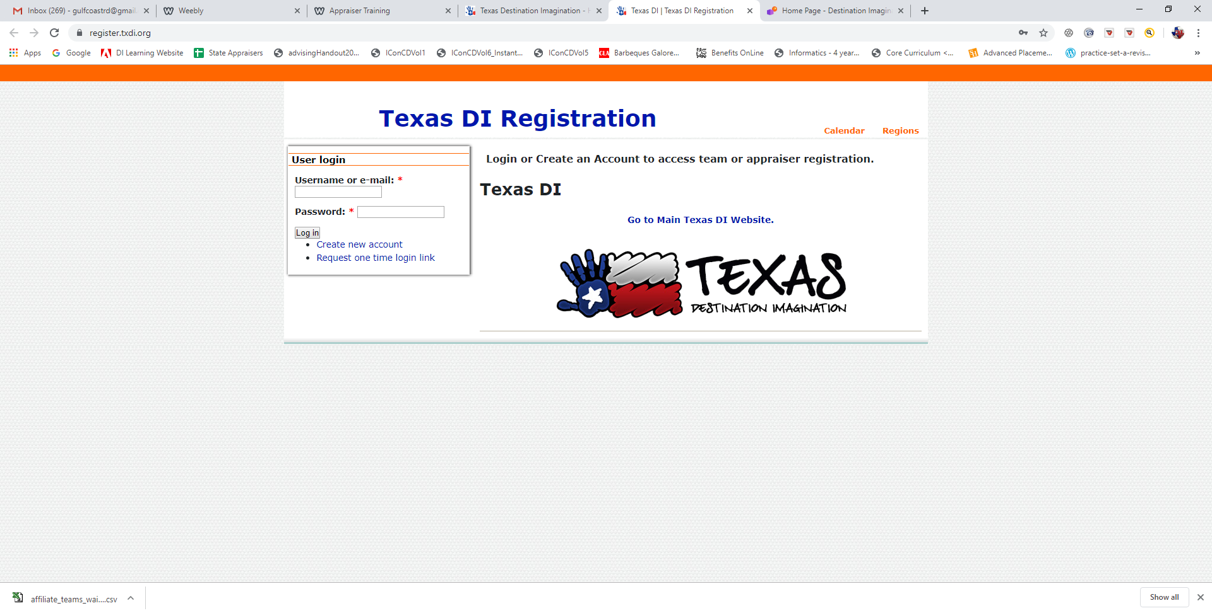

- Fill out the registration form

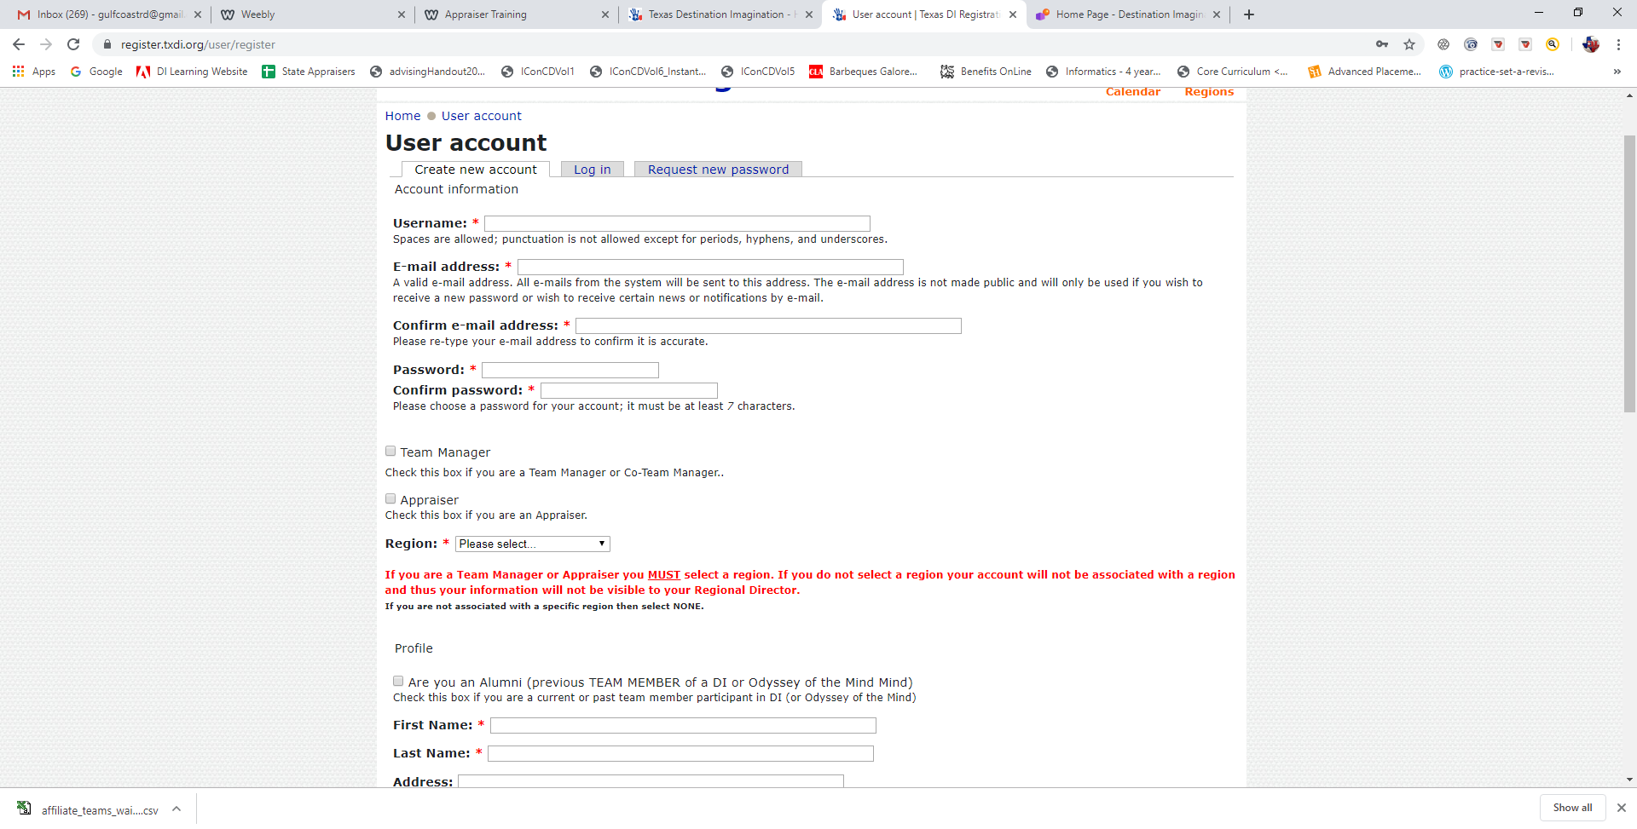
Notes on filling out the registration form:

- Make sure to check the Appraiser box
- Your region is Gulf Coast
- Once completed, click the “Create new account” button at the bottom of the form

You will then get a confirmation screen telling you need to validate your account through a link provided in an email. Your account will not be created until you complete the process.

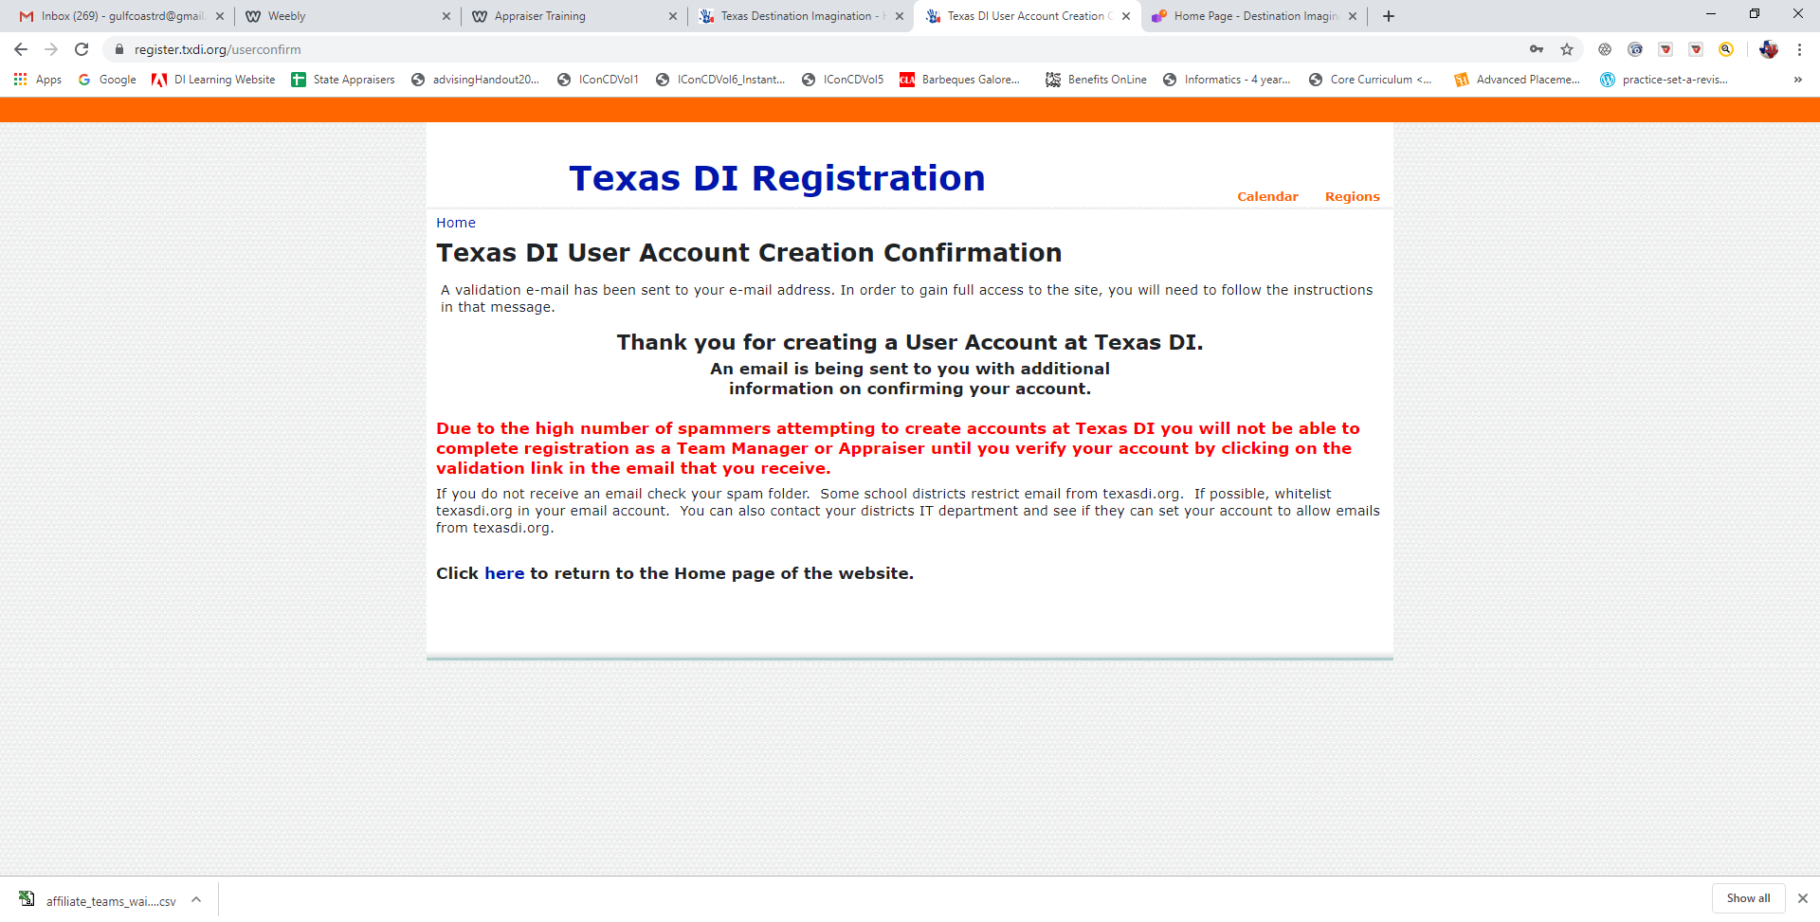

Once you click on the link in the email you will receive, you will be directed to a page stating that your account is validated.

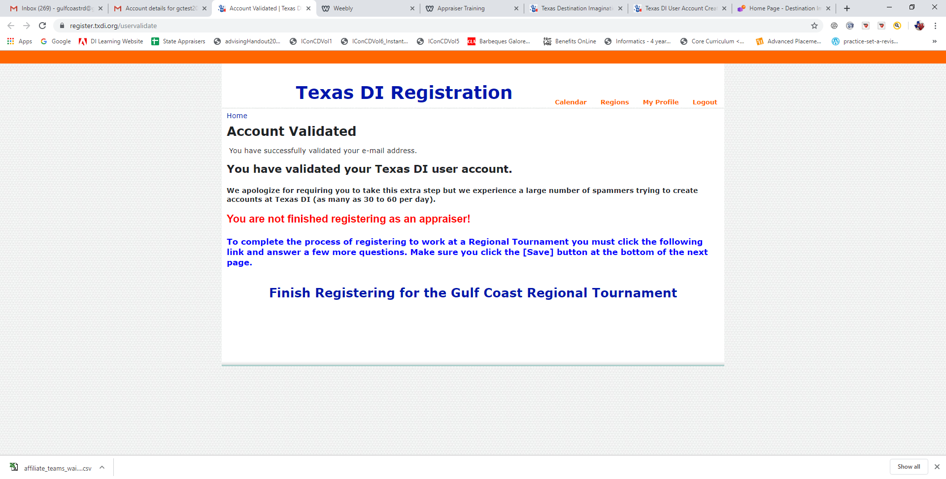

Next click on the “Finish Registering for the Gulf Coast Regional Tournament” link.

This will bring you back to the registration form that you were previously in. You will now have the opportunity to answer some questions about your preferences.

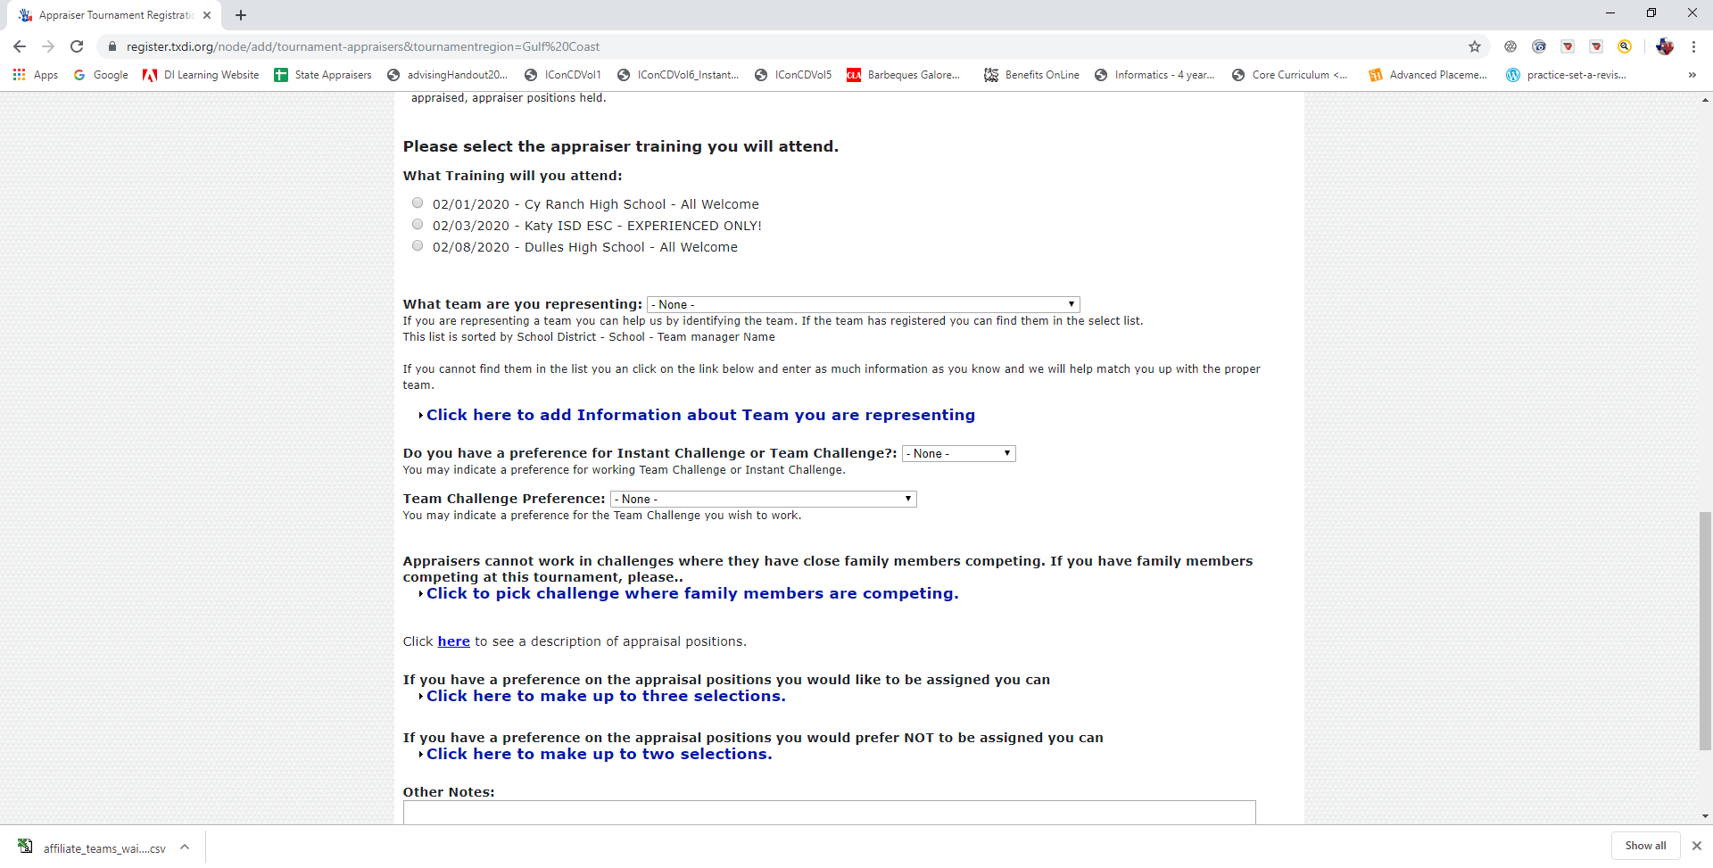

Notes on preferences:

- You are required to attend 1 appraiser training session. If you are an experienced appraiser, you can attend any of the 3 sessions listed. If you are a new appraiser, you must attend 1 of the 2 “All Welcome” sessions. New appraisers MAY NOT attend the experienced only session.
- Select the team you are representing from the dropdown. Please ask the team manager of the team you are representing if they have registered. If you do not see the team in the list, please click on the provided link and provide some information about the team, e.g. team manager name, school, etc.
- Select preference for appraising either for instant challenge or one of the team challenges.
- If you have family members competing, please indicate the challenge they are competing in.
- Make your preferences about the role you’d like to fill, we will do our best to accommodate you, but please be flexible!
- Make your preferences about the roles you would not like to fill.
- Other notes – tell us about any skill/knowledge that you have that might be helpful.
- If you are an experienced appraiser ( have appraised at least once before ), you can express your interest about appraising at the affiliate tournament. I will contact you with more information.
- Don’t forget to hit Save at the bottom.

You’re all set, we’ll be in touch with more info!

Situation 2: You do have an account on www.texasdi.org

- Log into your account
- Click on the Appraiser link
- Click on Register for the Gulf Coast Regional Tournament
- If you do not see the register link, go into your profile and change your home region to “Gulf Coast”, save it, then click on Appraiser link again, and it should appear
- Fill out the form as above
- Voila! You’re Done.

